**Level 2**

With level 2 i had to change quite a bit to be able to use it on actual images. The main issue i had was creating the art and trying to understand which parts in the image was static or would be dynamically changed like the pumps. In a real life scenario im assuming id be given more information or the art itself which would result in a different outcome.

To start with level 2 the first i tackled was the background, form the assignment it was a side view of dirt grass and sky so i found a png for that online. All i did was make the body 100%x100% and added an image as background since that would be a static image.

body {

background-image: url(Images/bg.png);

background-size: cover;

height: 100%;

width: 100%;

}

From there i thought i had to add the borders / container, which would contain all the pump/pipes and the water level. I wanted to try and do this with out much alteration of the previous code / concepts but that did not happen as expected. I wanted to just make the background of my container the image but it would result on a lot of messy code like scaling the transforms then have to go to all other css classes and rescale to fit them.

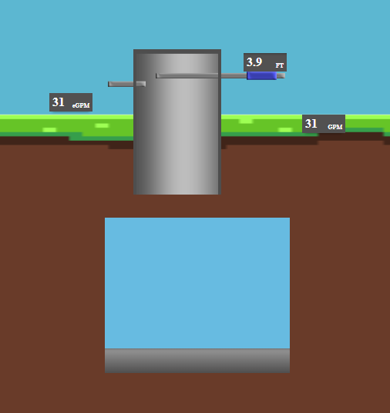

Which resulted in me altering the html slightly to be able to fit an image inside the container and slightly edit its width x height and pixel position to be aligned perfectly, since im assuming i created the art with the wrong pivot / centered position.

<div id="right-flow-level">

<h2 class="flow-number">0</h2>

<h3 class="flow-unit">GPM</h3>

</div>

<div id="left-flow-level">

<h2 class="flow-number">0</h2>

<h3 class="flow-unit">eGPM</h3>

</div>

<div id="simulation-container">

<img src="/Images/borders.png" class="border-img">

<div id="current-water-level">

<h2 id="water-level-number">0</h2>

<h3 class="water-unit">FT</h3>

</div>

<div id="water-level"></div>

<div class="pipe-container"></div>

<div class="pump-container"></div>

<div class="bottom-container"></div>

</div>

</div>

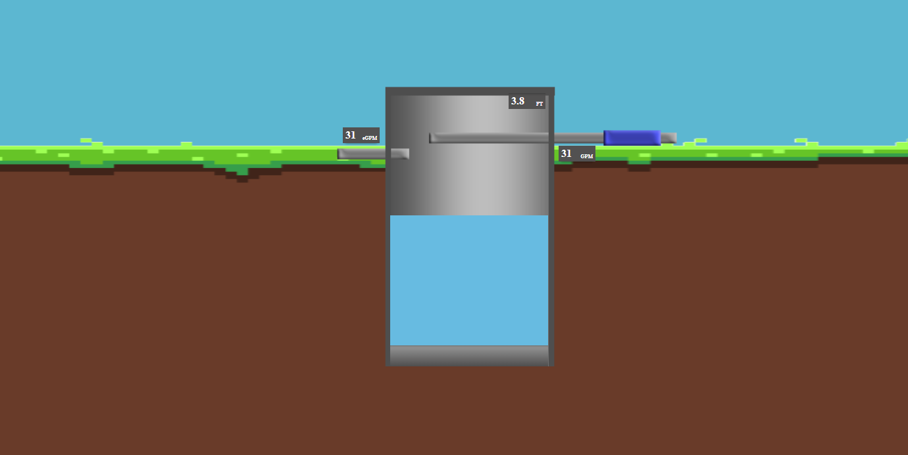

Since the container was the parent and the image was a child and it was sized in inheritance of the parent most other objects aligned perfectly like the flow level, water, and ft level.

So lastly id have to tackle was the pump / pipes, i used photopea which is free online and similar to photoshop, i also want to point out i did not spend much time making the art assets so please bare with the art choices… in level 1 i created the system to separate the pipes and pumps since i didnt have to think about the art yet and how i would be given, if the pump and pipe was separate art assets or combined. I figured it would be combined as if 1 or 2 pump count then the x amount of pumps would be hidden, and judging from the assignment concept the pump status was just a colored square over a pump image.

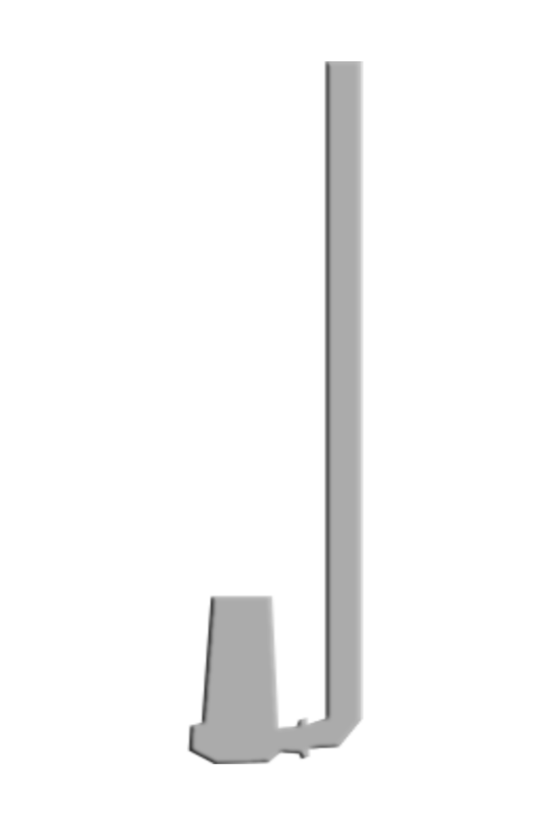

The main issue i had with the pumps was the order of it, in my containers i was using a percentage of width so if id have one pump image the image would come out big, if i had 3 it would be quite small and started to repeat since the image container kept readjusting based on the amount of content in it cause the images to be kinda funky.

From there i had to align the pump image which was the same ones from level one with the pumps regardless of what order it was spawning, whether only one pump which they should all start left to right.

NOTE: i do believe some approaches i've taken in lining up images or positioning might be kinda hard coded or not the appropriate way to do it. Next time i want to focus more on modularity and being given the right tools would be achievable.  
  
